Create an Instrumental Track Using Garageband Loops - iOS

Materials
iPhone or iPad with Garageband
Headphones (optional)

These steps will guide you how to create an instrumental project using loops from Garageband.

Step 1
Launch Garageband app

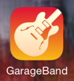

Step 2
Create a new project by clicking the + in the top left.

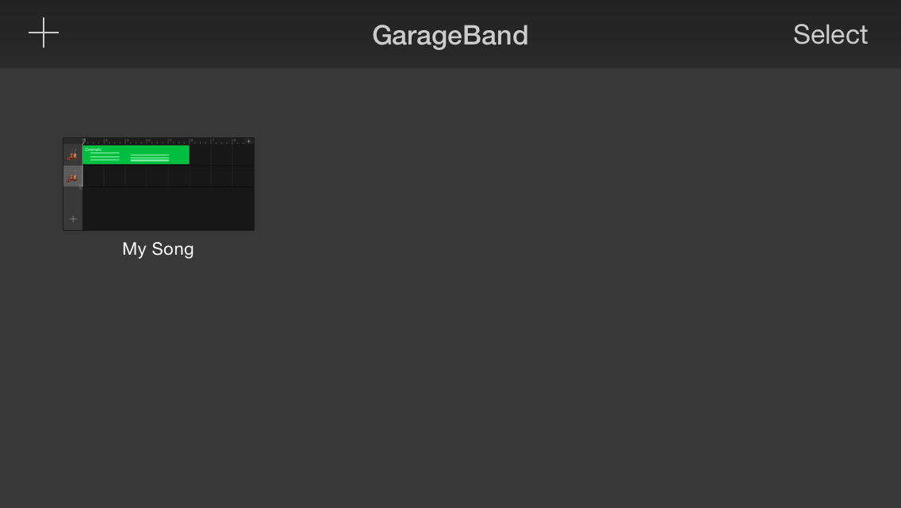

Step 3
Create an Audio track by scrolling left or right until you see the microphone icon and tapping it.

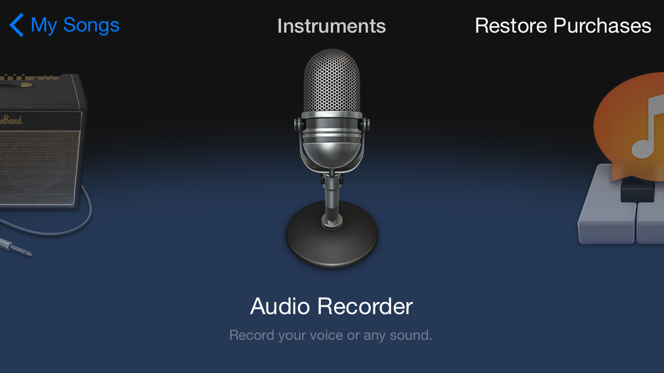

Step 4
Click the arrange window icon to get to the arrange screen.

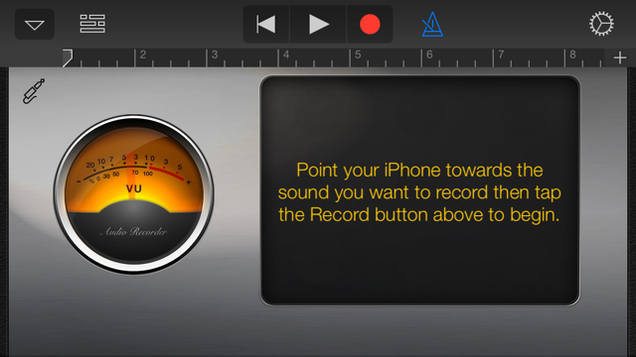

Step 5
Open a loop browser by clicking the Loop icon in the top right corner of the screen.

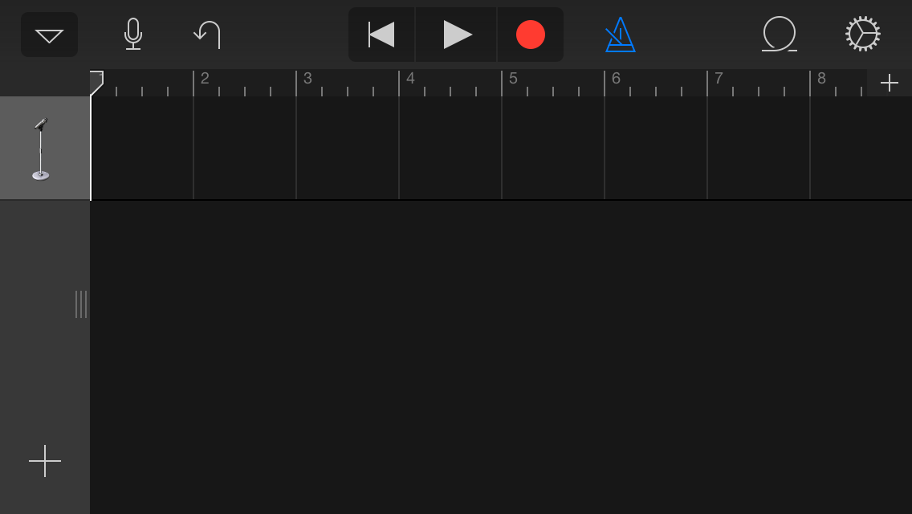

Step 6
Browse the loops and find one you’d like to add. Drums are a good start. Tap to audition them.

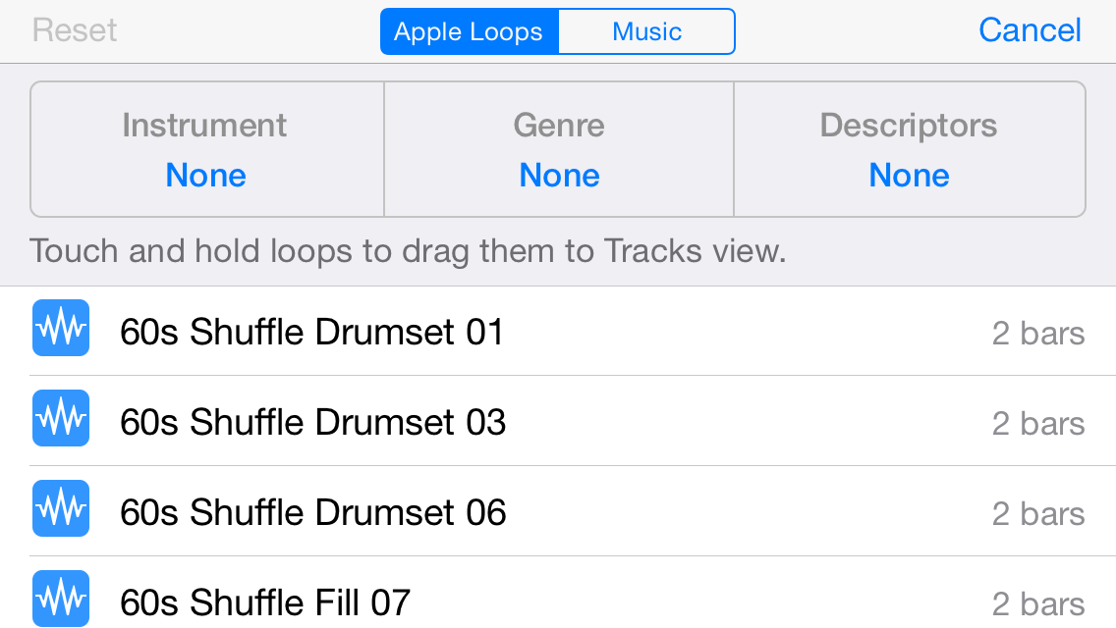

Step 7
Drag the loop you want to use into the arrange page by touching the loop and dragging your finger to the left.

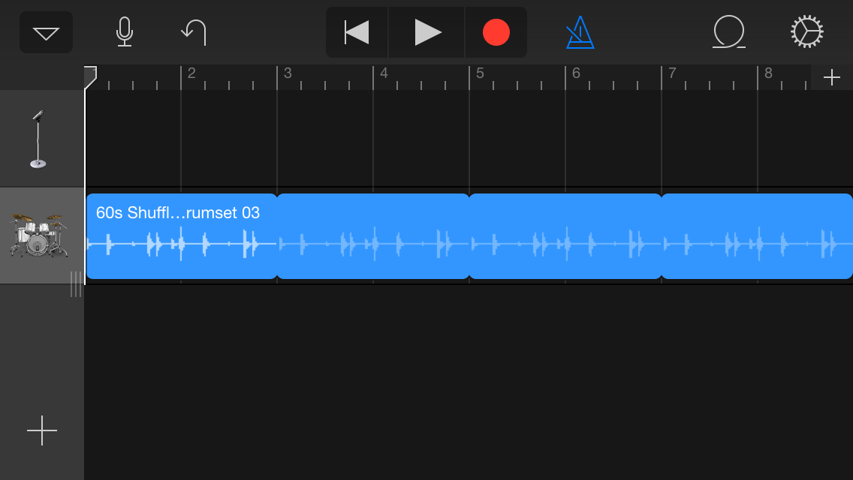

Step 8
Add more loops. You can browse loops by category.

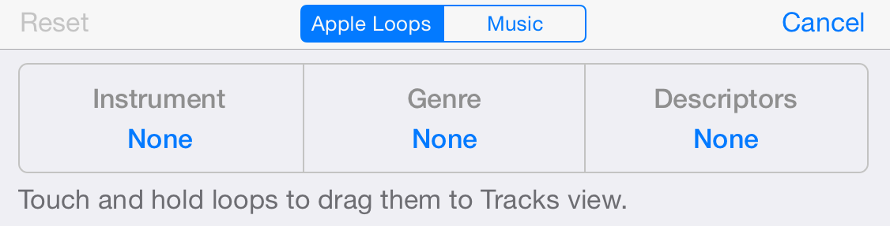

Step 9
Save and name your song. Touch the down arrow, select my songs, and your song will save automatically.

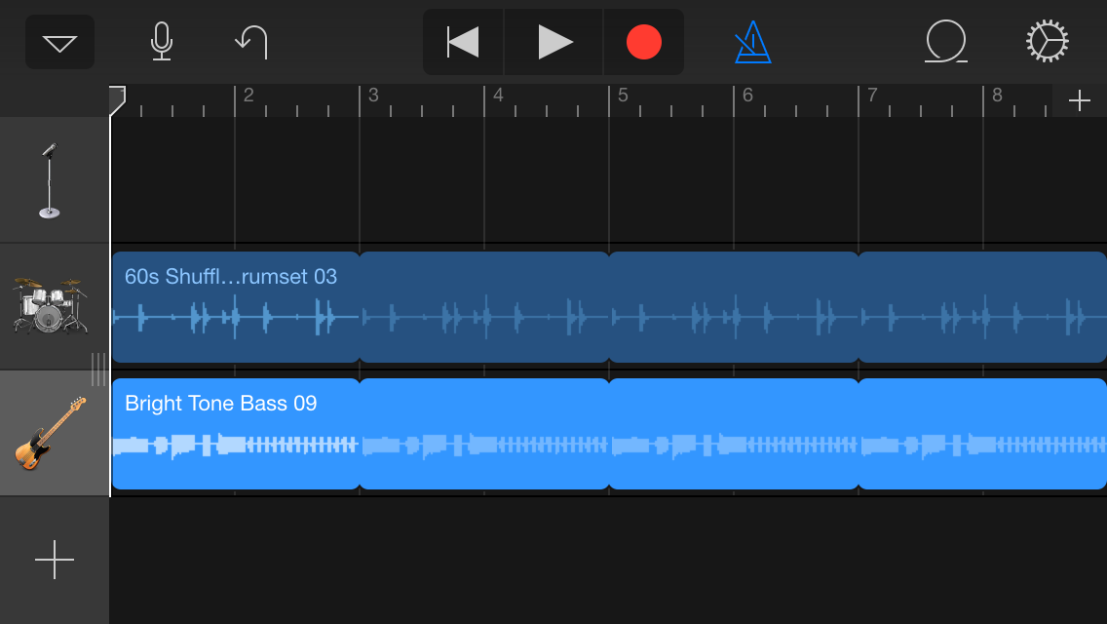

Tap the song name in the song browser to rename.

