Create an Instrumental Track Using Garageband Loops - Mac OS X

Materials
Mac Computer or laptop with Garageband
Headphones (optional)

These steps will guide you how to create an instrumental project using loops from Garageband.

Step 1
Launch Garageband

Step 2
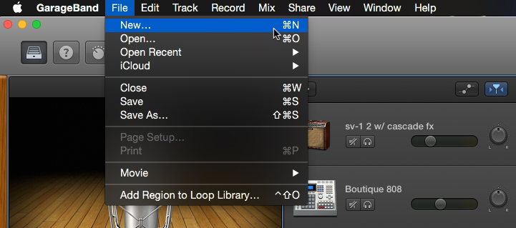
Open a new project (File New)and select an empty project from the templates.

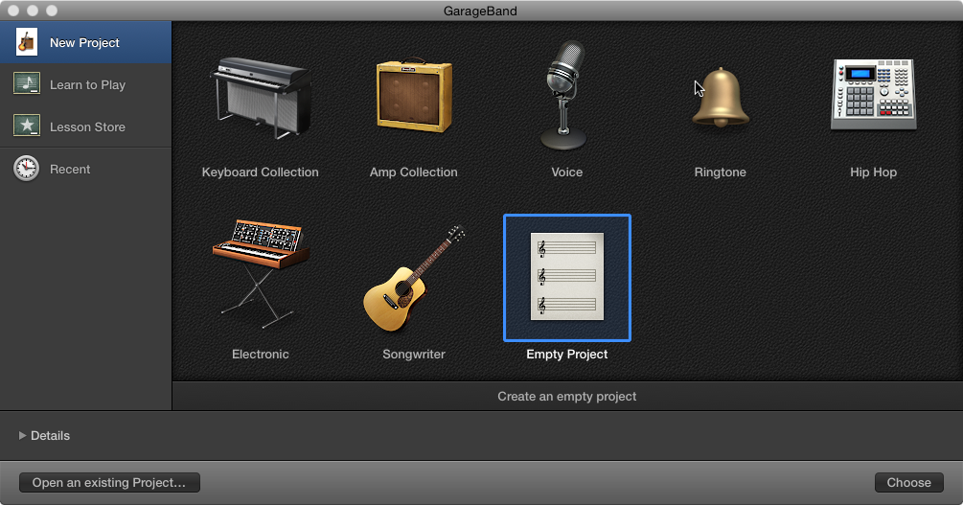

Step 3 (optional)
If this is your first time using Garageband loops you may have to download the additional content from apple. This is free but it will take some time. Garageband will have some loops already installed so if you are short on time, this step can be skipped. Click Garageband from the top left corner of your screen and select “Download Additional content.”

Step 4
Open your loop library on the top right corner of your screen. You can use the categories to browse through loops or you can type a phrase into the search field at the top. Audition a loop by clicking on its name.

Blue Loops are recorded audio and Green are MIDI Loops. Don’t worry, you can use both.

Open you loop library here

Loop Categories

Click individual loops to Audition

Step 5
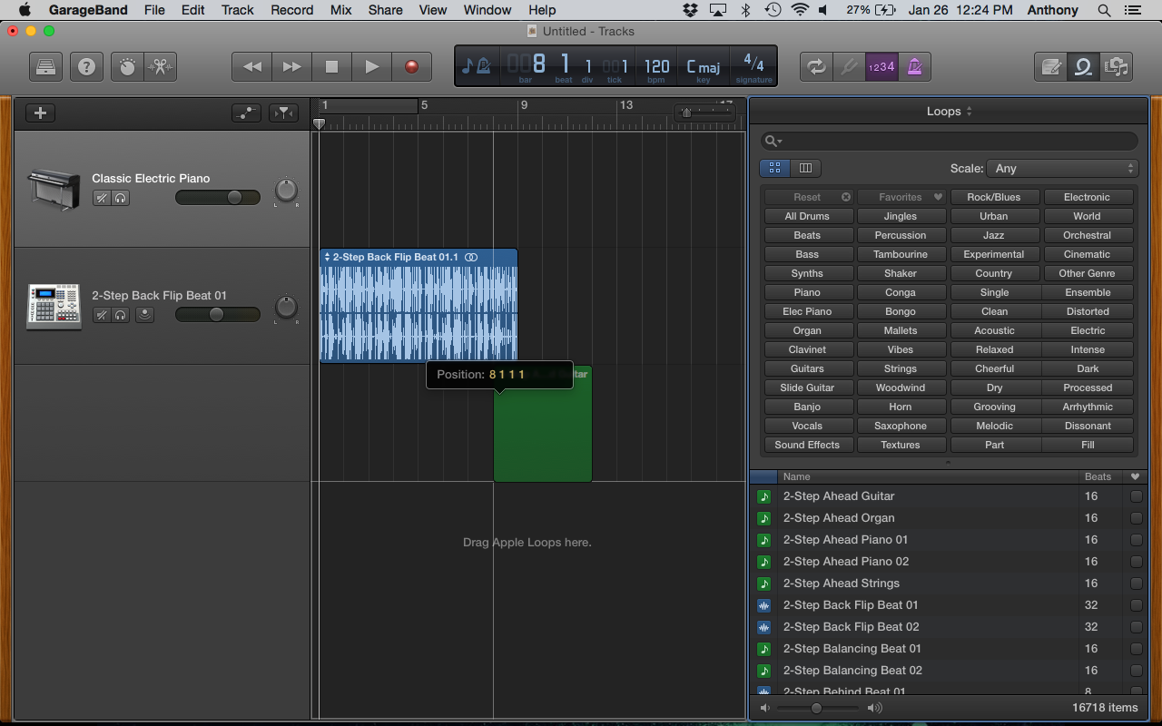
When you found a Loop you want to use, drag it to the middle section of your window to add it to the project.

Green MIDI loops being dragged to project.
Blue Audio loop already in the project.
Blue Audio Loop getting placed in project.
Step 6
Keep adding Loops! Every time you add a new loop you can either add it to an existing track or make a new one by dropping it under what you already have. If you are adding loops to existing tracks, try to keep green with green and blue with blue. For this project add 4-7 loop tracks.

TIP - To lengthen the bars of a loop hover over the top right of the loop. You will see the pointer turn into a circle with and arrow at its end. Click and drag the end of your loop to lengthen. This works for both Green and Blue loops.

Click and drag here

