Create an Instrumental Track Using Soundation - PC

Materials
PC with Soundation
Headphones (optional)

These steps will guide you how to create an instrumental project using prerecorded loops from Soundation.

Step 1
Go to www.Soundation.com and click the orange “Launch The Studio” button.

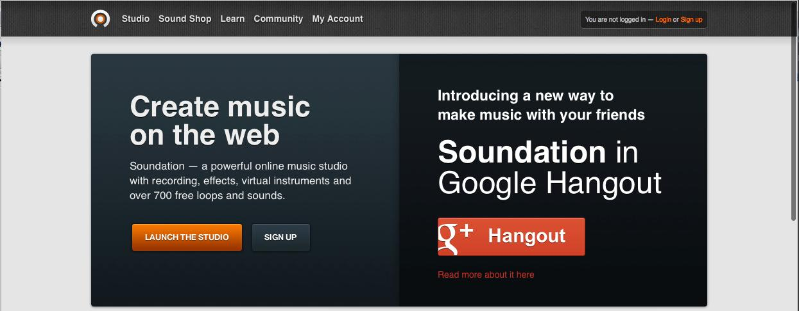

Step 2
Open the loop library on the right of your screen.

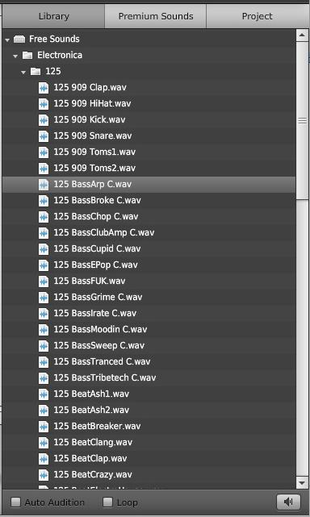

Audition Button

Audition the loops by double clicking on the loop itself or hitting the speaker icon in the lower right hand corner.

Step 3
Drag the loop you want to use into the middle section of your screen.

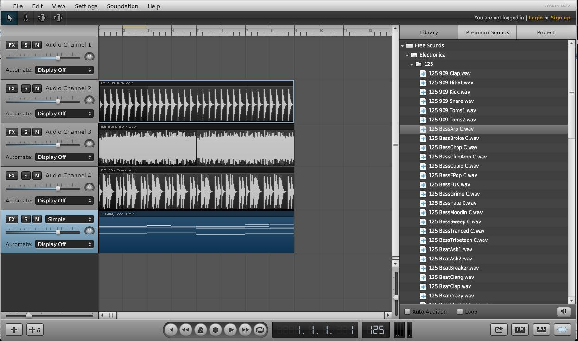

The first loop you drag into your project sets the tempo of your song.

Tempo 125

Step 4
Add more tracks by dragging in new loops or by clicking the + in the lower left the screen.

If you select a loop that has a different tempo (bpm), you will be asked if you would like to time stretch the loop to fit the current tempo. Click yes to ensure that your loops lock in.

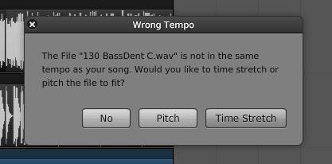Audio Clips from the Library can only be placed into Grey Audio Channels.

MIDI files from the Library can only be placed onto Blue Instrument Channels

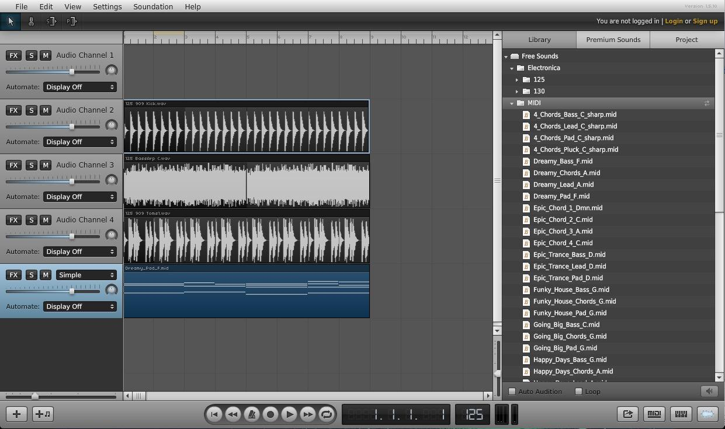

You can also resize your loops by clicking on the top right corner of the audio or MIDI track and stretching it out.

