Recording Vocals in Garageband (iOS)

Materials
Garageband on your iPhone or iPad
Headphones

These steps will guide you to record a vocal audio track using Garageband on iOS platform.

Step 1
Launch the app
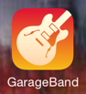

Step 2
Select your project.

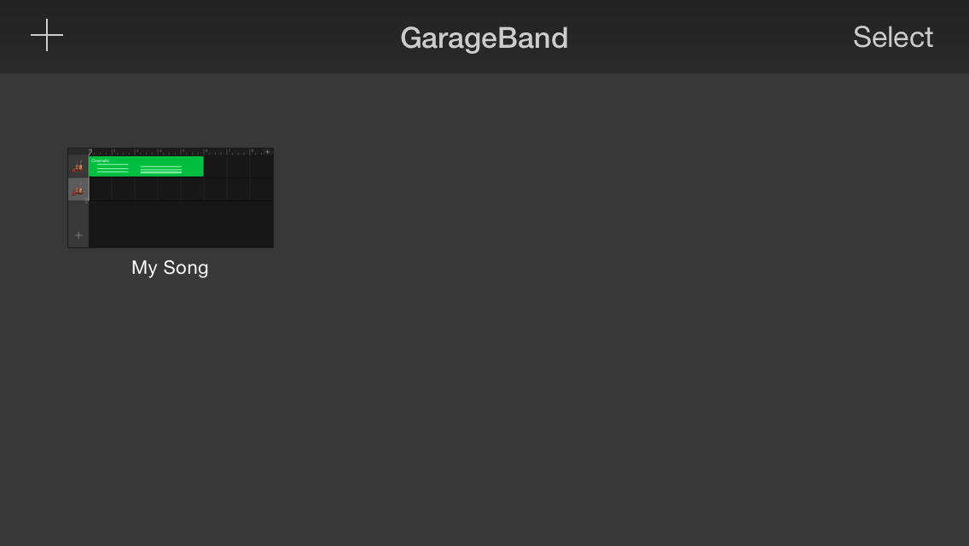

Step 3
Create and Audio track by scrolling left or right until you see the microphone icon and tapping it.
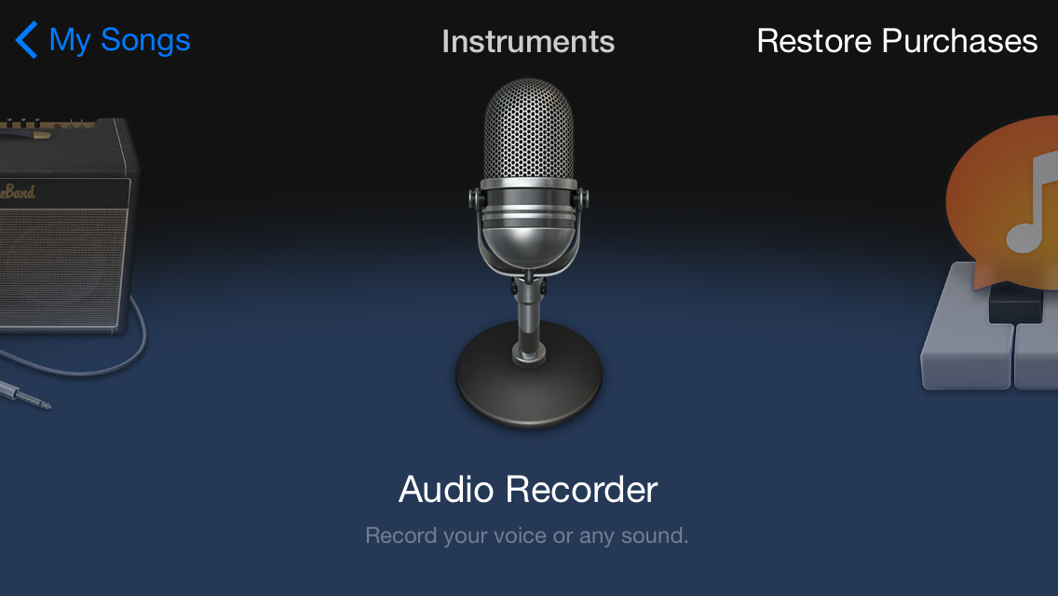

Step 4
Click the record icon to begin your recording.

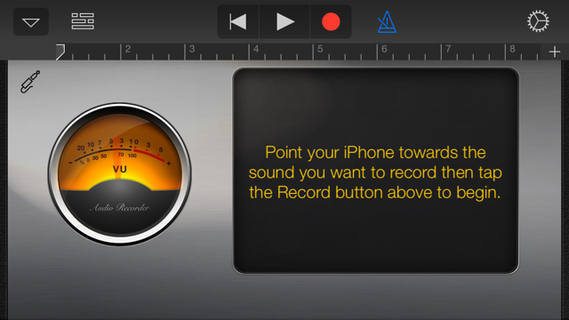

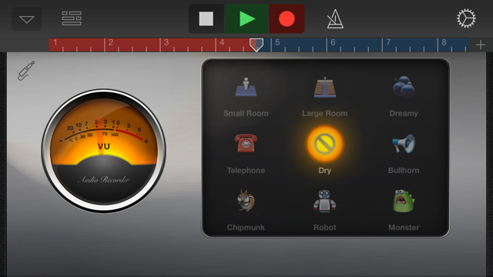

Step 5
If you want you can add some effects quickly by tapping the icons in the box on the screen. Dry means no effect at all.

Step 6
Tap the arrange icon to see your recording with the loops.

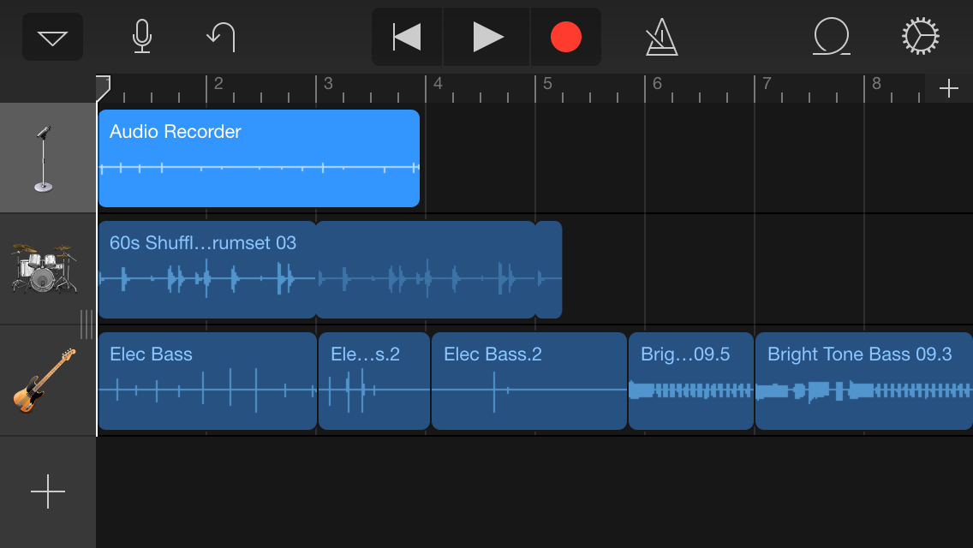

Step 7
Save and name the project just as you did in previous lessons.

