Recording Vocals in Garageband (Mac OS X)

Materials
Garageband on your computer
USB Microphone (optional)
Headphones(optional)

These steps will guide you to record a vocal audio track using Garageband on a Mac OS X platform.

Step1
Plug in any microphone or audio equipment you are using. If you don’t have any, don’t worry. Just use your computer’s built in microphone.

Step 2
Launch the app from your applications folder or your Launchpad Icon.

Step 3
Garageband will most likely open the last project you worked on. If this is not your loop project follow this step. In the menu bar select file > then Open

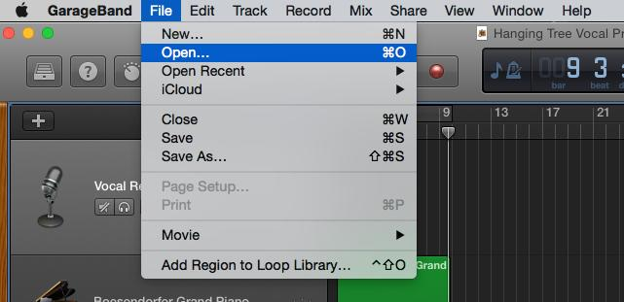

Step 4
Select the instrumental project you already created in Garageband.

Step 5
Click the Plus to Add a New Track

Step 6
Select an Audio track

Vocal Track

Step 7
If you have a USB microphone or audio digital interface it will most likely be selected for you by Garageband already. (If it doesn’t, follow this step: If you’re using the computer’s built in microphone, make sure it says input one and “my instrument is connected with: Built in Microphone”. Select your “input” or what your microphone is plugged into from the menu your audio interface by clicking the > next to “ My instrument is connected with:”
Here I am using a Quartet. Then click create.

Pick your device from the menus here

Step 8
Click the record button and record your work!
Record Button

Vocal Track with Recorded Audio

